Students’ Perception and Expectations on English as Second Language in the Sub-urban High School Context

A Thesis
Presented to the Board of Examiners
in Partial Fulfilment of the Requirements
for the Master Degree in English Education



By
Rahma Widiasari
2020105222

GRADUATE PROGRAM
UNIVERSITAS MUHAMMADIYAH PURWOKERTO
2021
Supervisor Approval
The student submits the thesis for examination:
Name :
ID Number :
Department : English Education
Thesis title:

Supervisor’s Approval:
I confirm that the thesis written by the above-named student meets the scholarly standards for the degree and is therefore eligible to proceed to an examination by the board of examiners of the Department of English Education, Graduate Program of Universitas Muhammadiyah Purwokerto

Purwokerto, 15 September 2021
Supervisor,

Condro Nur Alim, Ph. D
NIK. 2160xxx.

Approval of Thesis for Submission

This Thesis titled: Students’ Perception and Expectations on English as Second Language in Sub-urban High School Context
by Rahma Widiasari

has been examined by the board of examiners on 7th December 2021
All feedback, corrections, and suggestions recommended by the examiners have been considered and revision has been accordingly made by the student.

The Board of Examiners certify that the thesis is eligible for submission.

Supervisor

Condro Nur Alim, Ph. D
Examiner I

Asih Ernawati, Ph. D
Examimer II

Shanty Hawanti, Ph. D

Purwokerto, 15th December 2021
Graduate Program Director

Dr. H. Furqanul Aziz, M. Pd.
Statement of Authorship

I hereby confirm that the thesis entitled “ -------------------------” is an original and authentic work written by myself and it has satisfied the rules and regulations of Universitas Muhammadiyah Purwokerto with respect to plagiarism. I certify that all quatations and the sources of information have been fully reffered and acknowledged accordingly.
I confirm that this thesis proposal has not been submitted for the award of any previous degree in any tertiary institution in Indonesia or abroad

Name : Rahma Widiasari
ID Number : 2020xxxxx
Department : English Education

15 December 2021
Signature
(Rahma Widiasari)

Dedication Page

Abstract
Widiasari, R., 15 December 2021, Department of English Education
Students’ Perception and Expectations on English as Second Language in Sub-urban High School Context
Thesis Supervisor: Condro Nur Alim, Ph. D

Xxxxxxxx xxxxxxxxxxxxxxxxxxx xxxxxxxxxxxxxxxxxx xxxxxxxxxx xxxxxxxxxxxx xx xxxxxxxxxxxxxxxxxxxxxxx

Keywords: ESL, High School Students, Perception, Expectation

Acknowledgment

List of Figures

List of Tables

Table of Contents

Title page i
Supervisor Approval ii
Approval for Thesis Submission iii
Statement of Authorship iv
Dedication Page v
Abstract vi
Acknowledgment vii
List of Figures viii
List of Tables ix

Chapter I: Introduction 1
1.1. Background of the Study
1.2. Research Questions 8
1.3. Objective of the Study
1.4. Contribution of the Study
1.5. Definition of Terms
1.6. Organization of the Study

Chapter II: Literature Review 20
2.1.
2.2.
2.3
2.4.
2.6. Previous Studies

Chapter III: Methodology 45
3.1. Qualitative Research
3.2. Researcher Role
3.3. Setting and Participants
3.4. Provision of Trustworthiness
3.5. Data Collection Methods
3.6. Data Analysis

Chapter IV: Analysis and Discussion 55
4.1.
4.2.
4.3.
4.4.
Chapter V: Conclusion and Recommendations 110
5.1. Conclusion
5.2. Recommendations

References 117
Appendix A: Informed Consent Form 120
Appendix B: Letter of Permission 121
Appendix C: Interview Guide 122
Appendix D: Source of Data Chart 125

CHAPTER I
INTRODUCTION

CHAPTER II
LITERATURE REVIEW

Picciano (2017) has described the model of Anderson’s Online Learning Model. Reprinted with permission by Anderson, T. (2011). The theory and practice of online learning. (2nd Edition). Edmonton, AB: AU Press. The model shows:
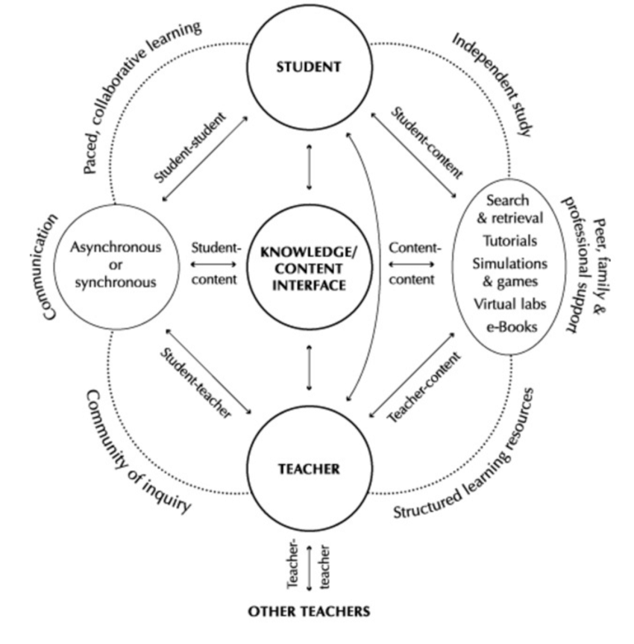
Figure 1: Anderson’s Online Learning Model

CHAPTER III
METHODOLOGY

Table 1: Research Population
Grade | School 1 | School 2 | School 3 | Total
 | 53 | 2 | 50 | 105
 | 88 | 3 | 54 | 145
 | 84 | 2 | 40 | 126
Total Number of Population |  |  |  | 376

Table 5. The Level of Achievement

Mean | Interpretation of the mean
4.21 – 5.00 | Very Low
3.41 – 4.20 | Low
2.61 – 3.40 | Moderate
1.81 – 2.60 | High
1.00 – 1.80 | Very High

CHAPTER IV
ANALYSIS AND DISCUSSIONS

CHAPTER V
CONCLUSIONS AND RECOMMENDATIONS

REFERENCES
Adzharuddin, N. A. and Ling, L. H. (2019). “Learning Management System (LMS) among University Students: Does It Work?”. International Journal of e-Education, e-Business, e-Management and e-Learning, 3 (3): 248-249.
Ahlfeldt, S., Mehta, S., & Sellnow, T. (2005). Measurement and analysis of student engagement in university class where varying levels of PBL methods of instruction were in use. Higher Education Research and Development, 24(1), 5-20.
Anderson, T. (2012). The Theory and Practice of Online Learning. -----: AU Press

APPENDIX A

